GitHub Repository Weekly Progress and Development Report
Course: Web and Mobile Application
Prepared by: Noor Abdullah
GitHub Username: noorzk1
Repository: https://github.com/noorzk1/peuniweb2026

1. Introduction
This report presents the weekly progress completed during the Web and Mobile Application course. The GitHub repository was used to upload assignments, manage project files, organize source code, and track development updates throughout the semester. The repository demonstrates practical experience in web development, mobile application development, version control, debugging, and project organization using GitHub.

Week 1
During the first week, the GitHub repository was created and initialized for the Web and Mobile Application course. A basic README.md file was added to introduce the repository and provide course information.
The README file included:
- Student name
- Study field
- Semester information

Week 2
During the second week, a basic HTML webpage was developed for a fictional café called “Matcha Cafe.” The project focused on learning the structure of HTML documents and understanding how to create webpage content using headings, images, lists, sections, and footers.
The webpage included:
- A main title for the café
- An image banner
- A welcome section
- A product menu using unordered lists
- Footer information with location details
This project helped develop understanding of:
- HTML document structure
- Tags and elements
- Text formatting
- Image insertion
- Basic webpage organization
Technologies Used
- HTML5

Week 3
During the third week, the Matcha Cafe webpage was improved by adding external CSS styling and enhancing the overall user interface design. The project focused on learning how to connect HTML files with CSS files and apply visual styling to webpages.
A custom color theme was created using CSS variables, including pink and matcha-green colors to match the café concept. The webpage layout, typography, buttons, images, and sections were redesigned to create a cleaner and more modern appearance.
The project included:
- Linking an external CSS stylesheet
- Creating custom color variables using :root
- Styling webpage sections and containers
- Responsive image formatting
- Button and navigation styling
- Improving webpage layout and spacing
- Custom list styling using emojis
- Footer and typography customization
This week helped improve understanding of:
- CSS fundamentals
- External stylesheet linking
- Responsive webpage design
- User interface styling
- Color palettes and visual consistency
- Layout organization using CSS
Technologies Used
- HTML5
- CSS3

Week 4
During Week 4, we explored the MyMatcha website hosted on a live development server and tested its basic functionality.
The following links were used:
- https://dev-mymatcha.pantheonsite.io
- https://dev-mymatcha.pantheonsite.io/m-login
This week included:
- Accessing a live development website
- Testing navigation between pages
- Viewing the login page structure
This week helped improve understanding of:
- Website hosting basics
- Page navigation and structure
- Simple login page functionality
Technologies Used
- HTML5
- CSS3
- Pantheon hosting platform

Week 5
During Week 5, we implemented basic analytics tracking for the MyMatcha project using Google Tag Manager and Google Analytics 4.
Tracking details:
- GTM ID: GTM-TNTBH5D6
- GA4 Measurement ID: G-LZB6SJL1NH
The main focus of this week was tracking user interaction with the website, specifically monitoring views of the Menu page through a custom GA4 event tag.
This week included:
- Setting up Google Tag Manager container
- Connecting GA4 property to the website
- Creating a custom event tag for Menu page views
- Testing tracking functionality
This week helped improve understanding of:
- Web analytics fundamentals
- Event tracking in Google Analytics 4
- Tag management using GTM
- Monitoring user behavior on webpages
Technologies Used
- Google Tag Manager (GTM)
- Google Analytics 4 (GA4)
- HTML5
- CSS3

Week 6

During Week 6, we developed the brand identity and visual direction for the MyMatcha project, focusing on creating a cohesive aesthetic experience for a modern café brand.

🏛️ Brand Concept: The Sun-Drenched Minimalist MyMatcha is a curated, aesthetic café experience inspired by minimalism and warm natural light, designed as a calm and Instagrammable space in Prague.

1. Brand Personality & Tone

Vibe: Cozy, aesthetic, and golden (Japandi-inspired design)

Tone: Soft, inviting, effortlessly chic

Focus: Visual-first, calm digital experience with strong aesthetic identity

2. Color Palette
Role | Hex Code | Color Name
Primary | #f1e0c5 | Creamy Oat
Secondary | #c9b79c | Sun-Dried Sand
Accent | #71816d | Muted Matcha
3. Typography
- Headings: Cormorant Garamond (elegant serif, editorial style)
- Body: Quicksand (soft, modern sans-serif, highly readable)
5. Tasks Completed
- Created brand persona for MyMatcha café in Prague
- Designed UI direction using minimalist aesthetic principles
- Generated mobile UI concept for matcha menu using brand colors (#f1e0c5, #71816d)
- Created AI image prompts for marketing visuals

6. Visual Assets
- Before Design Screenshot 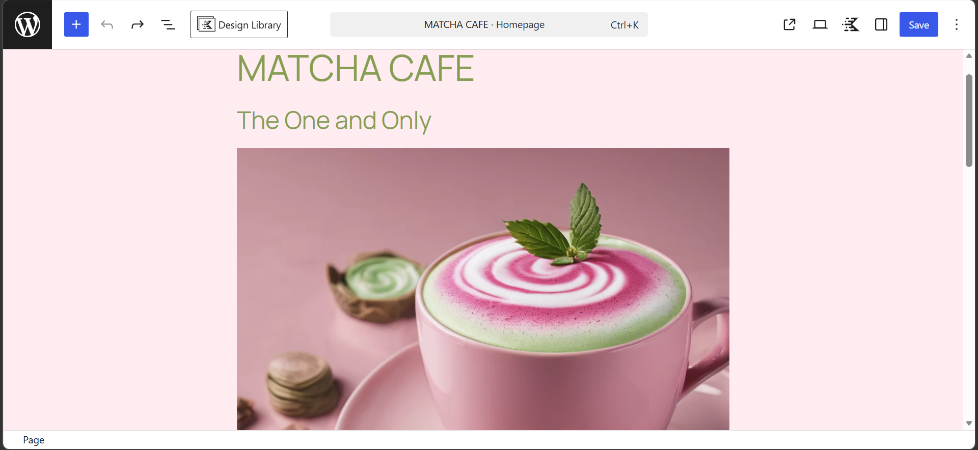
- After Design Screenshot
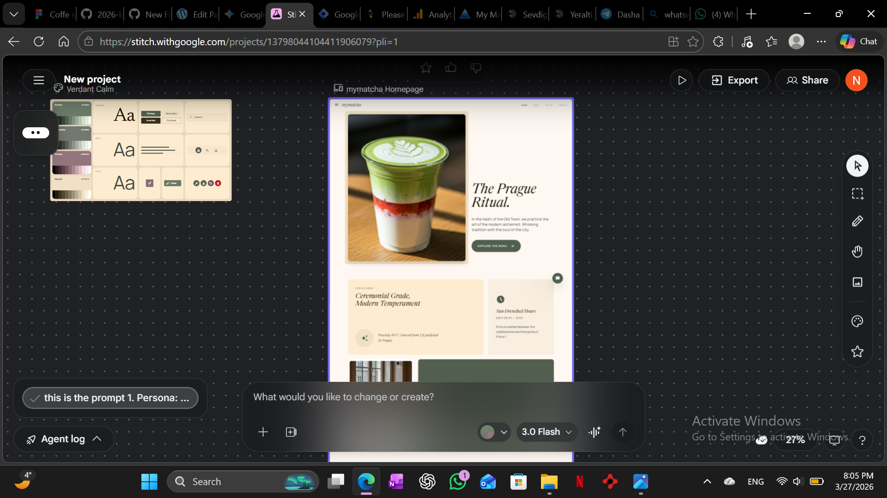
This week helped improve understanding of:
- Brand identity creation
- UI/UX aesthetic design principles
- Color psychology in design
- Prompt engineering for visual generation
Technologies Used
- HTML5
- CSS3
- Design tools / AI image generation

Week 7
During Week 7, we focused on user experience design principles, data collection ethics, and website performance optimization using Lighthouse.
1. Value Exchange
We offered users a free matcha sample or a personalized recipe guide based on their “First Choice” selection in the form. This encouraged engagement while providing clear value in return.
2. Data Minimization
Only essential fields were included in the form: Name, Email, and a preference dropdown. These were chosen because they provide necessary contact information for rewards and help the café understand customer product preferences without collecting unnecessary data.
3. Audit Results
- Initial Performance score: 59
- Main issue identified by Lighthouse: unoptimized image files (JPG/PNG), which slowed down page loading before being converted to WebP format
Visual Evidence
- lighthouse-report.png
- 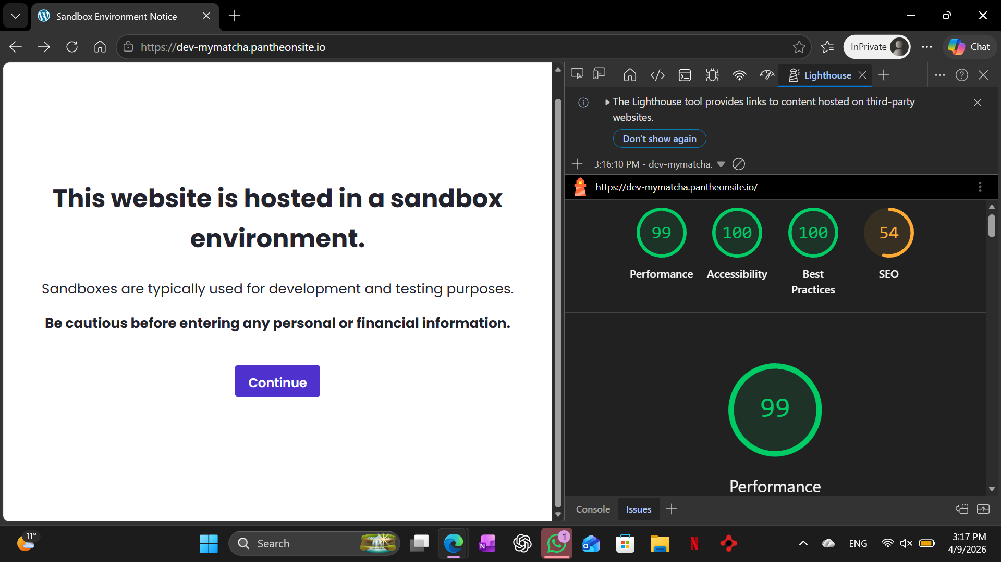
- This week helped improve understanding of:
- UX value exchange principles
- Ethical data collection (data minimization)
- Website performance auditing using Lighthouse
- Image optimization for faster load times
Technologies Used
- Google Lighthouse
- HTML5
- CSS3
- Image optimization tools

Week 8
During Week 8, we focused on improving the website’s visibility and how it appears when shared on social media platforms.
Work Completed
- Commit message: Optimize SEO and Social Sharing tags
- Added and improved meta tags for better search engine optimization (SEO)
- Improved social media preview data (Open Graph / sharing tags)
Visual Evidence
- Social preview screenshot
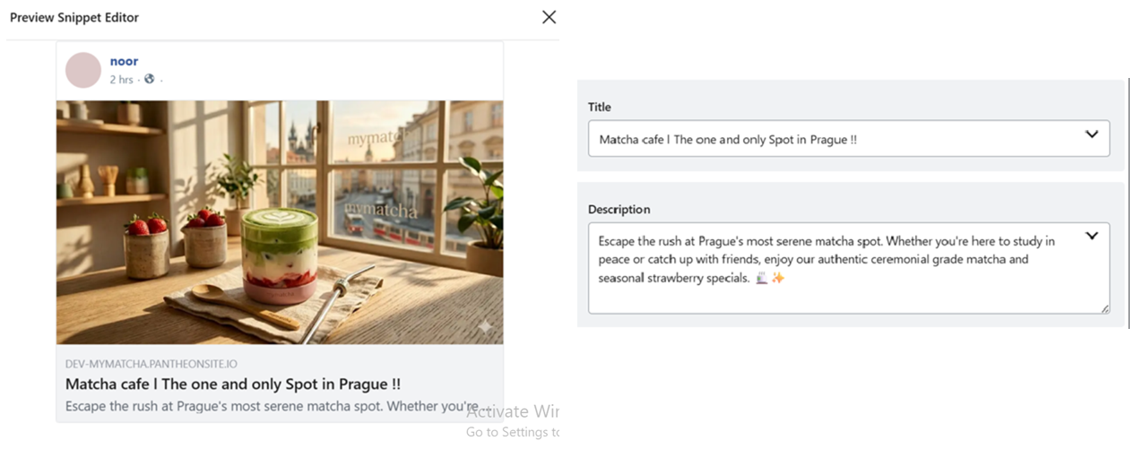
This week helped improve understanding of:
- SEO fundamentals
- Meta tags and Open Graph structure
- How websites appear when shared online
- Improving digital visibility and branding consistency
Technologies Used
- HTML5
- CSS3
- SEO meta tags

Week 9
During Week 9, we tested the functionality and user flow of the MyMatcha online ordering system, focusing on usability, product structure, and inventory behavior.
1. Friction Test
We analyzed the number of clicks required for a user to complete an order from landing on the homepage. Typical flow: Homepage → Order Online → Add to Cart → View Cart → Checkout → Place Order (Approximately 4–6 clicks total)
2. Product Logic (Variable Product)
The Latte was defined as a variable product. Users were given different options for customization, including:
- Soy milk
- Cow milk
- Oat milk
3. Inventory Behavior
We tested the inventory system using the “Brownie” product. After placing a test order with stock set to 1, the product was either marked as “Out of Stock” or removed from the Order Online menu depending on stock configuration.
This week helped improve understanding of:
- E-commerce user flow and friction analysis
- Variable product configuration
- Inventory management logic
- Customer ordering experience design
Technologies Used
- E-commerce platform tools
- HTML5
- CSS3

Week 10
During Week 10, we focused on marketing automation, discount strategy, and customer data segmentation for the MyMatcha project.
1. Coupon System
The coupon code used was: FRESHMAN26
- Discount: 15% off orders over 100 CZK
- Target: Freshman student demographic
- Purpose: Encourage first-time purchases and increase conversion rate
2. Automation
A "Welcome Email" automation was created for new newsletter subscribers.
- Trigger: 1 minute after user joins mailing list
- Subject line: "Welcome to the Matcha Crew! Your 15% discount is inside"
3. Data Strategy
A preference question was added asking users for their favorite drink:
- Strawberry Matcha Latte
- Almond Latte
- Espresso
This data is used for audience segmentation to personalize marketing emails (e.g., dairy-free recommendations for Almond Latte users).

Visual Evidence
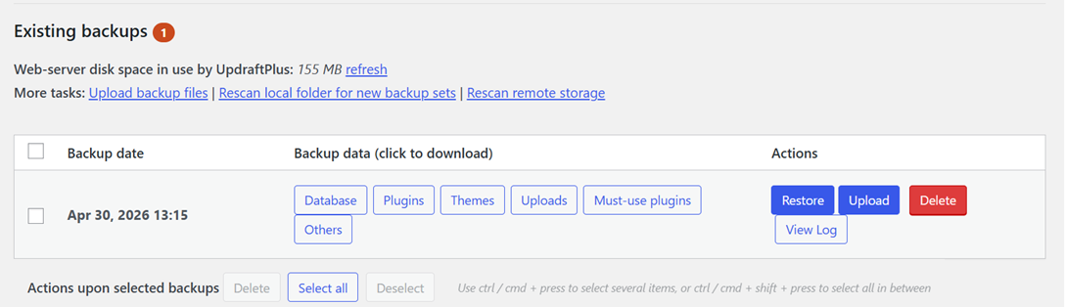
This week helped improve understanding of:
- Discount and coupon strategy in e-commerce
- Email marketing automation workflows
- Customer segmentation and personalization
- Data-driven marketing decisions
Technologies Used
- E-commerce platform tools
- Email automation system
- HTML5
- CSS3

2. Skills Developed
- Web development fundamentals
- Mobile application development
- Git and GitHub usage
- Version control and repository management
- Debugging and testing
- Project organization
- Frontend development basics
- Problem solving and technical analysis

3. Challenges and Solutions
Throughout the development process, several challenges were encountered including organizing project files, fixing coding errors, and maintaining proper version control. These challenges were solved through testing, debugging, reviewing source code, and using GitHub effectively to manage updates and project progress.

4. Conclusion
The GitHub repository demonstrates the weekly progress and technical development completed during the Web and Mobile Application course. Using GitHub improved project management, version control skills, and software development organization. The repository reflects practical experience gained in web and mobile application development throughout the semester.

